REMOTE CONTROL APP

Aim: to create remote control app

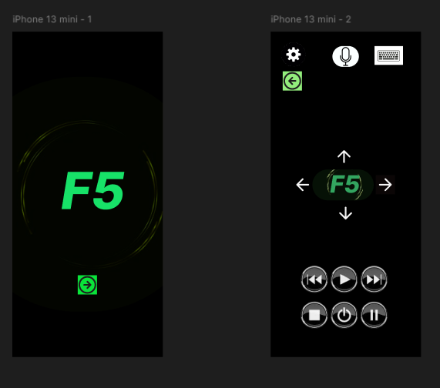

Procedure:

**Step 1: Set Up Your Figma File**

1. **Create a New File**:
   * Open **Figma** and select **File > New** to create a new design file.
2. **Create Frames (Artboards)**:
   * For a **desktop website**, you can use a frame size of **1440x1024px** (common web design resolution) or **1920x1080px** for a large-screen experience.
   * Press **F** to create a frame. Each frame will represent a different screen of the website (e.g., Home, About, Services, Portfolio, Contact).
   * Name each frame based on the page you're designing (e.g., "Home Page", "About Us", "Services", "Portfolio", "Contact Us").

### **Step 2: Design Key Pages for the Agency Website**

The main pages for a **design agency website** usually include the following:

* **Homepage**: Introducing the agency, core services, and call-to-action (CTA) to get in touch or view more work.
* **About Us**: The agency's story, mission, and team.
* **Services**: Detailed breakdown of the services the agency offers.
* **Portfolio**: Showcasing the agency’s past projects.
* **Contact Us**: How potential clients can reach the agency.

Let’s walk through designing each page in Figma.

#### **1. Homepage Design**

The homepage should capture the essence of the agency’s creativity and expertise. It serves as a first impression, so it needs to be visually appealing and easy to navigate.

* **Hero Section**:
  + **Large Background Image or Video**: Use a high-quality image or a video that highlights the agency's design style (e.g., an animated video of the team working, or showcasing a finished design).
  + **Agency Branding**: Include the **agency’s logo** prominently at the top. If you don’t have one, you can use Figma’s text tool and create a simple logo for now.
  + **Tagline**: Add a tagline like **“We craft creative digital experiences”** or **“Designing the future, today”**.
  + **CTA Button**: A button like **"View Our Work"** or **"Start Your Project"** should be prominently placed below the tagline to drive user action.
* **Navigation Bar**:
  + Include a top **sticky navbar** with links to **Home**, **About**, **Services**, **Portfolio**, and **Contact**.
  + The navbar should have a clean, minimalist design with a logo on the left and links or a hamburger menu on the right (for mobile-friendly designs).
* **About Section**:
  + Provide a brief introduction to the agency (e.g., “We are a full-service design agency that specializes in branding, UI/UX design, and web development”).
  + Include a **small image** of the team, office, or a conceptual design.
* **Services Preview**:
  + Show **3-4 key services** (e.g., Branding, UI/UX Design, Web Development, Motion Graphics).
  + Create **service cards** with icons or images representing each service and a brief description.
* **Portfolio Showcase**:
  + Include a **carousel** or **grid** of project thumbnails (images or screenshots of previous work). Each project could link to a **detailed case study page**.
* **Client Logos**:
  + If applicable, display logos of your major clients as a trust-building feature (e.g., “We’ve worked with companies like XYZ, ABC, etc.”).
* **Footer**:
  + Include essential **contact information**, social media links, and links to the privacy policy or terms of service.

#### **2. About Us Page Design**

The **About Us** page should convey the agency’s story, mission, values, and team members. This is where you build trust and showcase the human side of your agency.

* **Hero Section**:
  + A background image that reflects the agency’s personality (e.g., a photo of the team, office, or creative workspace).
* **Agency Story**:
  + Add a **short description** of the agency’s history and mission. You can use a two-column layout: one for text and one for an image or video.
  + Example: “Founded in [Year], our mission is to deliver exceptional digital experiences to brands around the world.”
* **Core Values/Philosophy**:
  + Use a **list** or **icons** to highlight your agency’s core values (e.g., **Innovation**, **Collaboration**, **Quality**).
* **Meet the Team**:
  + Show pictures of your team members in a **grid layout** with their names, roles, and short bios.
  + Optionally, you can have an interactive hover effect where hovering over a person’s image reveals their role and a brief description.

#### **3. Services Page Design**

The **Services** page is where you explain in detail what the agency offers, how the services are structured, and why clients should choose you.

* **Service Categories**:
  + Create a **grid** of the services offered (e.g., **Branding**, **Web Design**, **UI/UX**, **App Design**).
  + For each service, use **icons** or **images** that visually represent the service, and a short description underneath each category.
* **Service Detail Sections**:
  + Each service should have its own dedicated section. Add information such as:
    - What the service includes.
    - The process you follow.
    - Why it’s beneficial for clients.
* **CTA Button**:
  + Include a CTA like **"Contact Us to Discuss Your Project"** or **"Get a Quote"** at the end of each service section.

#### **4. Portfolio Page Design**

The **Portfolio** page should be the most visually engaging part of the website, showcasing the best of your agency’s work.

* **Grid or Masonry Layout**:
  + Use a **grid layout** for portfolio items. Each portfolio item should have an **image thumbnail** and a **short description** (e.g., project name, client name, and a brief summary).
  + Add hover effects that show more details or allow the user to click through to individual case studies.
* **Project Case Studies**:
  + When a user clicks on a portfolio item, it should take them to a **detailed case study** page.
  + A case study page should include:
    - Project overview.
    - **Problem statement** and **solution**.
    - **Process**: Show how the project evolved (e.g., wireframes, prototypes, design iterations).
    - **Final Outcome**: Screenshots of the final design.
    - **Client Testimonial** (optional).

#### **5. Contact Us Page Design**

The **Contact Us** page should make it easy for potential clients to get in touch with the agency.

* **Contact Form**:
  + Design a simple form that collects information like **Name**, **Email**, **Message**, and a **Submit Button**.
  + Keep the form clean and easy to fill out. You can use Figma’s **Auto Layout** to ensure proper spacing and alignment.
* **Contact Info**:
  + Include the agency’s **physical address**, **email**, and **phone number**.
* **Map**:
  + If you have a physical office, embed a **Google Map** showing your location.
* **Social Media Links**:
  + Include icons that link to the agency’s social media profiles (e.g., Instagram, LinkedIn, Dribbble, Behance).

### **Step 3: Visual Design**

#### **1. Color Scheme**

* Use **brand colors** that reflect the agency’s personality. Typically, design agencies use a **minimalistic color palette** with neutral tones (e.g., blacks, whites, and grays) combined with one or two vibrant accent colors (e.g., orange, blue, or green).

#### **2. Typography**

* Choose modern fonts that reflect the agency’s style. Popular options for design agencies include:
  + **Headings**: Serif or bold sans-serif fonts like **Montserrat**, **Poppins**, or **Playfair Display**.
  + **Body Text**: Clean, readable sans-serif fonts like **Roboto**, **Lato**, or **Inter**.
* Make sure to establish a **font hierarchy** for headings, subheadings, and body text to create visual structure.

#### **3. Imagery & Icons**

* Use high-quality **images** that reflect the agency’s work. Consider using **custom illustrations** or mockups if you want a unique look.
* Use **minimal icons** for service categories, navigation, and buttons. You can find icons in Figma plugins like **Feather Icons** or **Material Icons**.

#### **4. Spacing and Alignment**

* Use **Auto Layout** and **grids** in Figma to ensure that elements are aligned and spaced properly. Keep ample **white space** around text and elements to ensure the design feels open and easy to navigate.

### **Step 4: Prototype the Website**

* **Link the Pages**: In Figma’s **Prototype Mode**, link the different screens to simulate navigation between pages.
* **Interactions**: Add interactions like

Result:

SuccesFully created Remote Control App.